Interoperability through European Collaboration (iTEC)

Project: iTEC

Supervision 101 - iTEC

Version: -

25.05.2022

Total number of pages: -

Document Number: -

Document Group: UG

Produced by Dep.: SE

Produced with Tools: MS Word

|  |  |  |
| --- | --- | --- |
| Prepared for:  **Indra Sistemas** Ctra de Loeches, 9 28850 Torrejón de Ardoz Madrid, Spain |  | Prepared by:  **Indra Sistemas** Ctra de Loeches, 9 28850 Torrejón de Ardoz Madrid, Spain |

|  |
| --- |
| This document has been prepared by Indra for the iCAS Lower Airspace project within the framework of the dossier, the number of which is stated above, and may not be used for purposes other than the established ones, nor totally or partially reproduced, passed on or divulged to any person without the expressed authorization of DFS, LVNL or Indra and in accordance with the use rights defined by the iTEC Centre Automation System contract. |

**Table of Contents**

**1.** **Document Info** 3

1.1 What is Supervision 101 – iTEC? 3

1.2 What does Supervision 101 – iTEC include? 3

1.3 How should I use this document? 3

**2.** **Introduction to iTEC systems** 4

2.1 Where does Supervision play a role? 4

**2.2** **Chapter 2 Summary** 5

**3.** **Introduction to iCAS** 6

3.1 iCAS timeline 6

3.2 General View 6

3.3 Subsystems Area 7

3.4 Redundant Subsystems 7

3.5 Supervisor and Operational Position Buttons 8

**3.6** **Chapter 3 Summary** 9

**4.** **Introduction to NATS** 10

4.1 NATS Timeline 10

4.2 TSP General View 10

4.3 General Information Area 10

4.4 Main differences and additions 12

**4.5** **Chapter 4 Summary** 12

**5.** **Introduction to iGS – PANSA** 13

5.1 Introduction to iGS 13

5.2 Structures inside the system 14

5.3 General view of iGS 14

5.4 System Summary Area 15

5.5 Subsystems, Positions and Trackers area 15

5.6 Server Status Area and Control 16

5.7 External links and Services 16

**5.8 Chapter 5 Summary** 16

**6.** **Main Concepts and Glossary** 18

6.1 Glossary 18

6.2 Concepts to study for Supervision 19

# **Document Info**

## What is Supervision 101 – iTEC?

This document has the specific purpose of providing a written support to any person learning about the Supervision area of Indra, focusing only on the iTEC sector. If you are currently going through the Indra Talent Camp, or, you are entering the Supervision department, this document should be useful.

After reading this whole document, a beginner will be able to overcome several doubts that may have risen about iTEC and Supervision, and ultimately be able to have a better grasp of the key basic concepts. The learning curve might seem steep, since there are several concepts which may be confusing or difficult to understand, so do not worry if you are initially lost.

This document has been created with the help of other sources of information, such as the iCAS CMD User guide, the iGS Introduction PowerPoint and other documents found inside the Supervision area, therefore, this guide can be attributed to everyone inside the Supervision area.

## What does Supervision 101 – iTEC include?

Supervision 101 – iTEC contains an **introduction** to the following:

* iTEC
* iCAS
* NATS
* iGS – PANSA

Moreover, **summaries** are provided after each chapter, which recapitulate the most important pieces of information in those chapters. Various **footnotes** can be found at the footer of each page further explaining some concepts that may be important in the formation.

Finally, the last chapter will include a list of **concepts** that will be helpful towards your first few weeks in iTEC, since in ATM there is a vast amount of concepts. Therefore, this last section will emphasize a handful of these so you can **focus** on understanding them firsts.

## 1.3 How should I use this document?

Throughout your formation either on the Supervision area or in the Indra Talent Camp, there will be numerous introductory sessions to Supervision. This document tries to cover as much of the basic material given in these sessions. It is important to note that this document does **NOT** replace any of these classes.

The best use of this document is to have it as a support either during or after the formation, since it covers the basics needed to understand any of these systems. Hopefully, this document will clear any doubts that you may have of the key basic concepts. This document is recommended to be read in the **order that has been established**, since some explanations and footnotes for some concepts can only be found in the early chapters.

# **Introduction to iTEC systems**

The iTEC Alliance is made up of the three Founding Members, DFS, ENAIRE and NATS, plus four other members, Avinor, LVNL, Oro Navigacija and PANSA.

|  |
| --- |
| **iTEC Suite** is an advanced 4D trajectory-based ATM system that enables conflict detection, flight path monitoring and stripless operations, fully aligned with SESAR principles and ICAO Aviation System Blocks Upgrades (ASBUs) definition and evolution strategy.  In simpler words, **iTEC is a collaboration to create a common ATM [1]system to improve air traffic management, with the goal of increasing performance and cost efficiency**. |

|  |  |
| --- | --- |
| Air Navigation Service Provider (ANSPs)[2] | Air Traffic Management (ATM) system |
| DFS (Germany) | iCAS |
| ENAIRE (Spain) | SACTA |
| NATS (United Kingdom) | NATS |
| LVNL (The Netherlands) | iCAS-LVNL |
| Avinor (Norway) | Avinor |
| Oro Navigacija (Lithuania) | Vilnor 2.1 |
| PANSA (Poland) | PANSA |

## Where does Supervision play a role?

The Supervision team is responsible of the following:

* **Monitor** the different physical and logical elements and display statistics.
* **Authenticate**, Authorize and Audit users.
* **Control** system start up and version control.
* **Configure** the system management.
* **Automate** platform installation and parametrization.
* **System** messages and other events in the system.

|  |
| --- |
| The “Supervision software” shows the status of the different ATM system components, servers, CMDs, CWPs, etc… in other words, the software that the technical role would use to control and monitor the different system components and nodes in the system, such as the trackers, FDP, SNS, etc… |

Supervision allows the technical role to verify whether any structure (subsystem, node, links…) has any problems. This is a critical job since the partial fall of some systems can be considerably damaging and dangerous to both the customers and business. Therefore, having someone to ensure the functioning of the system is of vital importance.

## **Chapter 2 Summary**

* **iTEC** is a **collaboration** to introduce a **common airspace structure**, system architecture, **way of operating** and ATS system, delivering a better performance with an increased cost efficiency.
* **Supervision** is a small part of the whole ATM system, which is in charge mainly of **displaying** the different structures’ **status** and **system messages**, among many other things.
* The software created by supervision is used specifically by the **technical role**, which is in charge of configurations, system status, restarts, etc… but it is also in charge of some of the facilities provided for the operational role, such as sectorization.

# **Introduction to iCAS**

The iTEC Centre Automation System (**iCAS**) is the ATM system for the **ANSP** of Germany, **DFS**.

The iCAS system is comprised of three segments, iFDP, iCWP, iMAS and **iAF** (Additional Functions). Among the different components of the iAF system, you can find the Control and Monitor Support (**CMS**[3]) and the Control and Monitor Display (**CMD**[4]).

## iCAS timeline

VAFORIT was the previous ATM system developed by Indra that was used by DFS. Upon request of a better ATM system with more functionalities, the iCAS system was developed. As of currently, iCAS Phase II is being developed, with the new addition of The Netherland’s ANSP, LVNL.

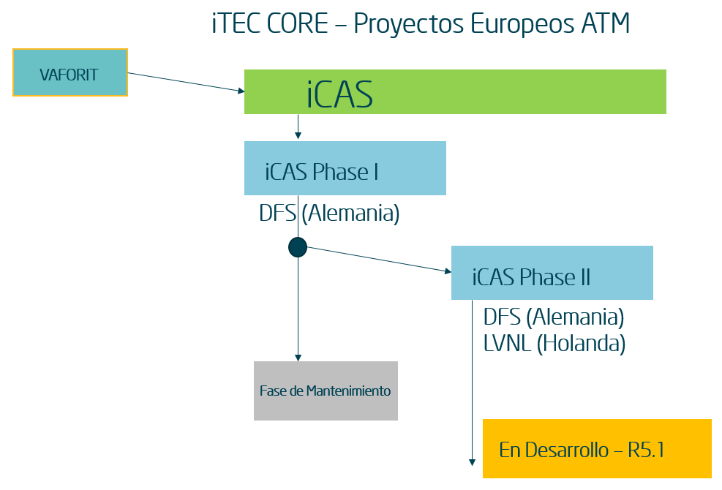

**iTEC Timeline**

Figura 1 - iCAS timeline

## General View

The CMD can be divided into three main areas, the Display Area, the Main Menu and, the Buttons Area.

* The Display Area’s main characteristics are the system message bar, the acknowledgement system and the user role.
* The Main Menu has all the functionalities that the different roles may need to use, such as modifying the sector plan or restarting the system.
* The Buttons Area shows the status of the different external links, subsystems, servers, CMDs and CWPs.

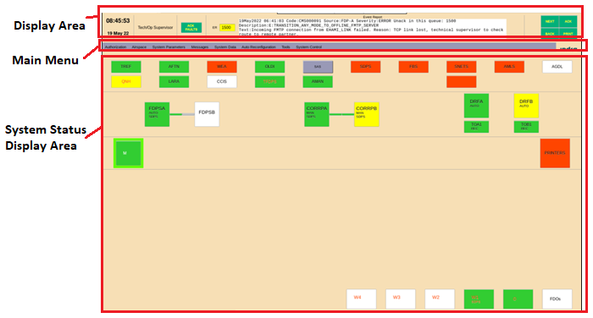

Figura 2 - CMD Main View

In the Buttons Area, we can further subdivide into four sections, the external links, the subsystems, the CMDs and, the CWPs.

## External links Area

In the external links area a few notable subsystems are:

* TREF (Time Reference – NTP Network Time Protocol – Keeps the different subsystems and external links synchronised with a time server that provides a very precise common time source)
* FMTP (Flight Message Transfer Protocol – OLDI, SAS, AGDL… Communication stack based on TCP/IP)
* SNETS (Safety Net System – Prevent near or imminent hazardous situations)
* SDPS and FBS (Surveillance Data Processing System and Fall Back System – Give track information to the systems)

The latest version included three new subsystems: CCIS, LARA and IA.



## Redundant Subsystems

This next section covers the three servers that appear in the iCAS system, the iFDP, CORRP and, DRF.

* The iCAS Flight Data Processor (iFDP) is the Computer Software Configuration Item (**CSCI**[5]) in charge of several different functionalities related to flight plan data and management, such as flight state, messages, etc...
* The **Correlation Processor** (**CORRP**) is the **CSCI** in charge of correlating the flight plan with the tracks that the SDPS or FBS is providing.
* The **Data Recording Facility** (**DRF**) is the **CSCI** responsible for recording every traffic flow exchange that happens between different CSCIs.

The iFDP, the CORRP and the DRF are separately in a tandem cluster. This means there are two iFDP nodes connected together, where one is active while the other one is in reserve. When one fails, the node that is in reserve takes over. This **redundancy** ensures that there’s always an iFDP, a CORRP and a DRF working. The process of one instance taking the active role from the other instance is known as a **Switchover**.

An important characteristic of the iFDP and CORRP tandem cluster is that a LAN known as **OP-SBY LAN** connects them together. This ensures that both iFDP **instances** and both CORRP instances are **synchronised**.

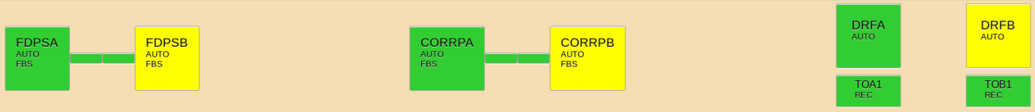

Figura 3 - Redundant Subsystems Buttons

## Supervisor and Operational Position Buttons

The supervisor position buttons allow the operator to control the status of all supervisor position subsystems and to monitor the status of the printers. The iCMD displays which which is the active iCMD with a green halo. If there is only one iCMD (the active one), and you disconnect it, you would no longer see a screen.

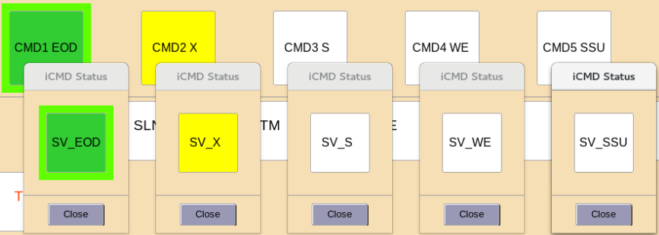

Figura 4 - Supervisor Position Buttons

The operational position buttons allow the controllers to control the status of the Controller Working Positions (**CWP**[6]) and Flight Data Operators (**FDO**[7]) positions. iCWP and iFDO subsystems are organised into groups, according to functionality, physical location or by any other criteria as specified in the configuration or **adaptation data**[8].

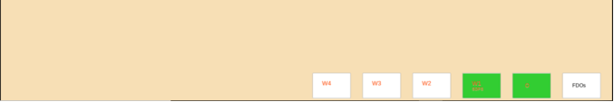

Figura 5 - Operational Position Buttons

## **Chapter 3 Summary**

* DFS is the German ANSP and the ATM system created by Indra for the former is iCAS.
* iCAS Phase I is the product currently being used by DFS and maintained by Indra. iCAS Phase II is currently being produced for DFS and LVNL, the Dutch ANSP.
* The CMD is the technical display of iCAS, while the CMS is the engine or brain. Note: The CMD’s requirements are much easier to understand than the CMS’s requirements.
* iCAS allows the user to:
  + Log in with different roles
  + Create and check system messages and, acknowledge them
  + Check the status and configure the different subsystems, servers, CMDs and CWPs

among others things…

# **Introduction to NATS**

The ATM system used by the ANSP of the United Kingdom, NATS, has similar functionalities to the iCAS system. Two of the most noticeable differences are that the HMI display is known as **TSP** [9](Technical Supervisor Position) instead of CMD, and, the TSP display has a different arrangement to the CMD.

## NATS Timeline

As it can be seen, NATS timeline has several branches. In Version 2.1, Indra created a branch for Lithuania. In Version 2.5, a branch for PANSA was created. These branches still use the CMS and TSP provided by the main branch of NATS, but in different ways. As it will be shown later on, PANSA uses the TSP as a secondary display.

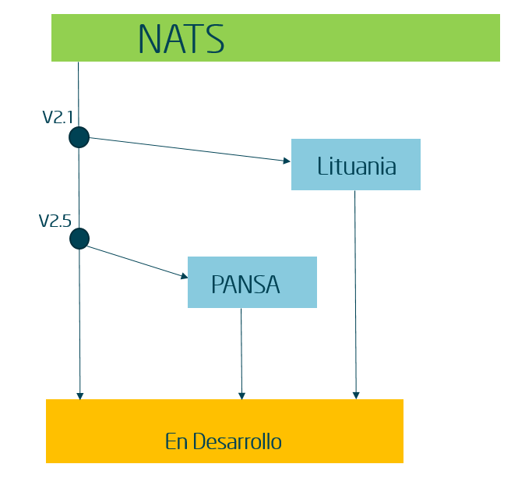

Figura 6 - NATS' timeline

## TSP General View

The TSP is made up of three distinguishable areas:

* General Information Area
* Subsystem Access Area
* Navigation Bar

## General Information Area

The General Information Area is always visible. All the subsystem blocks that make up the system are displayed. The technical role can monitor the global state of each subsystem through the colour code of each subsystem or node. There are several parts to the General Information Area, therefore, only the most important ones will be mentioned.



Figura 7 - NATS Main View

**The System Information Area** is placed on the topmost layer of the TSP. The CMS obtains the current state of the different subsystems and calculates the final system state, which on correct functioning of the system should appear green.

The **Menu Area** is also at the top of the **Main Window**. It contains different options that allow the technical role to interact with the system, such as the Configuration or the Statistics.

The **External Links & Services** area contain the global status for each external link. Similarly, the **Subsystems Area** contains the various subsystems tandems and their overall state. When clicking the different subsystems and links, the corresponding scenario is shown on the **Subsystem Access Area**, which is the bottom half of the TSP display.



Figura 8 - FDP Scenario

The **Alarms Area** is the equivalent to the **Event Report Area** of the iCAS CMD interface. It contains different filters that can be applied to view different views, just like the CMD. One major difference is that NATS has an audible alarm when an event report with severity “Critical” is received.

Finally, there is a **Navigation Bar** which allows the user to navigate between opened windows in the Subsystem Access Area (the bottom half of the screen).

## Main differences and additions

A couple of differences that are noteworthy when compared to the iCAS CMD are the following:

* Critical Event Reports contain an audible alarm that can be turned off if required.
* The subsystem area shows the tandem for ALL subsystems.
* The CWP Subsystem Area contains a filter to check the multiple states a CWP can be in.
* Unlike iCAS, there is a separate section for external links and subsystems scenarios.
* Online management of users, including adding, modifying and deleting users and roles.
* Checks the check-sum of the different installed files to prevent accidental modifications or malicious software
* Additional commands.

## **Chapter 4 Summary**

* The display of NATS is known as Technical Supervisor Position (TSP). The CMS is still the “brain” of the system, just like in iCAS.
* Out of the NATS timeline, different systems have been developed, including Lithuania’s V2.1 and Poland’s PANSA.
* NATS has the same functions as iCAS, excluding some additions or modifications that have been done.

# **Introduction to iGS – PANSA**

The ATM system created for the Polish ANSP, **PANSA**, includes several features that exemplify the evolution of ATM and iTEC systems as a whole. PANSA uses two supervisions, CMS, which comes from the NATS route, and LSUP (Local Supervision). Moreover, PANSA uses the **iGS** [10]display, which is the modern HMI/platform implemented in the new iTEC software.

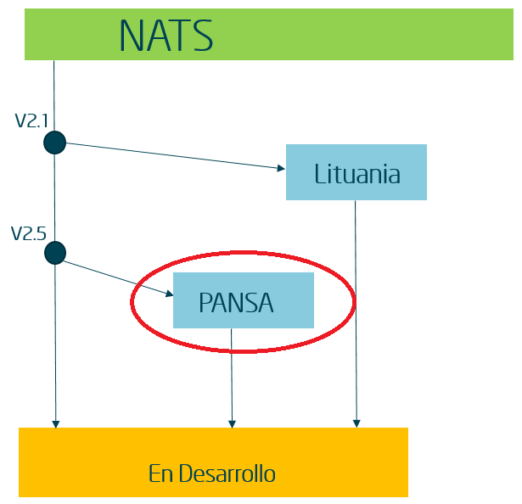

Figura 9 - PANSA's timeline

## 5.1 Introduction to iGS

iGS is a key component since it allows the ATM system to be quite flexible. There are several features that this platform has that the CMS and LSUP cannot provide. These are:

* **Integrates both CMS and LSUP** into “one system”. As long as any other supervision core can be understood, iGS can implement it.
* **Acts a display** just like the CMD and TSP. Since PANSA comes from NATS, the TSP still remains, but is used as an auxiliary screen instead.
* **Creates different structures**, such as node sets, and allows modifying these.

Since two supervision cores are used, distinct subsystems are being controlled by one of the two cores. As of currently:

* **LSUP Context**: TTM, SNS, SD-FEP
* **CMS Context**: FDP, CWP, RS, PCM, IOMP, SWIS, TSP

That said, iGS does share similarities with the LSUP core these are the node states:

* **Technical State**: Operational, Degraded, Failed, Non-Operational… (generally used for Subsystems)
* **Phase**: Starting, Started, Stopping, Stopped… (generally used for Nodes and Links)
* **Operational mode**: Offline, Online in Use, Online Available, Releasing…

## 5.2 Structures inside the system

As mentioned, iGS is able to create and use the following **structures**:

* **Node**: Group of functionalities deployed in a (virtual) host

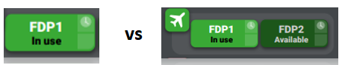

Figura 10 - Node vs Node Set

* **Node Set**: Nodes grouped by a common purpose
* **Service**: Provision of a specific functional need
* **Service Set**: Set of services grouped by operational category
* **Link**: Connection between two elements
* **Link Set**: Set of links grouped by operational type
* **Working Position Unit** (**WPU**): Working unit for a system operator



Figura 11 - System Status



Figura 12 - Subsystem

* **Working Position Set**: Set of working positions grouped by activity
* **Subsystem**: Group of heterogeneous elements that work together to provide functionalities
* **System**: The higher hierarchy element to be monitored

## 5.3 General view of iGS

The iGS HMI is the most modern out of all the displays mentioned. For the purpose of this guide, the iGS will be divided into 5 areas. The relevant characteristics will be detailed below.

* System Summary Area
* Subsystems, Positions and Trackers Area
* Server Area
* Control Room Area
* Links and Services Area.

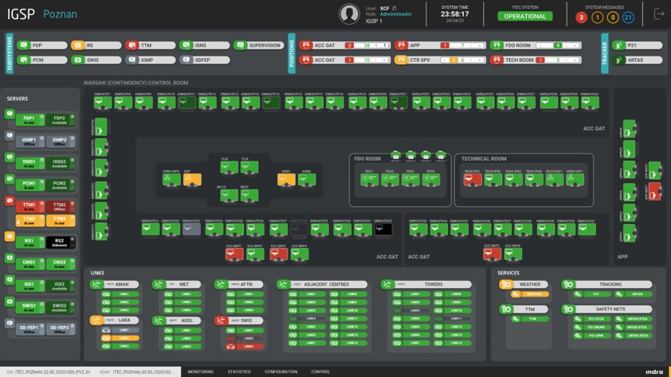

Figura 13 - iGS Display

## 5.4 System Summary Area

The “System Summary” is the topmost layer of the iGS interface. In the case of PANSA, the “System Summary” contains the user and role, the system time, the iTEC system and, the system messages.

These function similarly to the previous systems. The iTEC system status is calculated by taking into account the status of the different subsystems, positions, trackers, etc… The system messages has 4 counters, which represent the severity of the event reports that may appear. The severity by colour is coded as follows:

* Red: Critical
* Orange: Major
* Yellow: Minor
* Blue: Informational

When clicking on the system messages, an additional window appears with more information.



Figura 14 - System Summary Area

## 5.5 Subsystems, Positions and Trackers area

This section displays all the subsystems in the iGS, right next to the positions of the control room. The subsystems display a colour, which represents the status. On the other hand, the positions display five different numbers, which represents the number of positions that are on a certain state, for example, unreachable. Lastly, the status of the trackers are shown to the right.



Figura 15 - Subsystems, Positions and Trackers Area

## 5.6 Server Status Area and Control

On the server area, the user can monitor the different subsystems in their corresponding tandem cluster. The optimal combination for these is to have both instances fully operational, one being in “In use” state, and the other in “Available”.

The control room displays the positions of the different WPU. When clicking on an RDU, the different components appear in a small box, with their colour corresponding to their state.

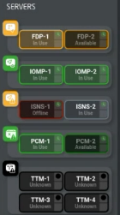

Figura 16 - Server Status Area

## 5.7 External links and Services

On the external links, the numerous types of links, including the adjacent centres can be monitored. Just like the external links, the services also appear with a colour, representing the status.

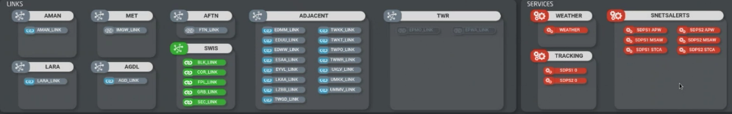

Figura 17 - External Links and Services Area

## **5.8 Chapter 5 Summary**

* PANSA uses the iGS intelligent display, which also adds several new features such as integrating the two supervisions and creating different structures.
* The creation of different structures such as node sets and subsystems allow for better functionality for the user.
* The iGS HMI displays the status of the different subsystems, positions, trackers, links and services. Additionally, the system messages are shown and classified in four different severities.

# **Main Concepts and Glossary**

## Glossary

|  |  |
| --- | --- |
| **Acronym** | **Meaning** |
| ANSP | Air Navigation Service Provider, an organisation that provides the service of managing the aircraft in flight or on the manoeuvring area. For example, ENAIRE. |
| ATM | Air Traffic Monitoring. The dynamic, integrated management of air traffic and airspace including air traffic services, airspace management and air traffic flow management |
| CMD | Control and Monitor Display. The display of the iCAS system. |
| CMS | Control and Monitor Support. The “brain” of the iCAS system. |
| CSCI | Computer Software Configuration Item. A basic building block. Group of software treated as a single entity with a clearly defined function. |
| CWP | Controller Working Position. Display/System used by the Operational Controller to monitor aircrafts and airspace. |
| ENV | Environmental Data. Data needed by ITEC services, which are not included in flight plans and/or radar information. Data concerning conditions surrounding ATS. |
| FDO | Flight Data Operator. Secondary display used by the Operational Controller to check flight plans and data. |
| FDP | Flight Data Processor. Main subsystem of the ATM system. |
| FP | Flight Plan. Specified information provided to air traffic services units, relative to an intended flight or portion of a flight of an aircraft. |
| HMI | Human-Machine Interface. Interface between system operators and the functionality specific to the task being discharged. |
| iAF | Indra Additional Functions. Every functionality or system that is not the FDP or CWP. |
| iCAS | The ATM system of DFS and LVNL. |
| iGS | Indra Global Supervision. Indra Global Supervision, an intelligent display and platform that provides several useful functions such as creating bigger logical structures. |
| iTEC | Interoperability through European Collaboration |
| LSUP | Local Supervision. Supervision created by Indra. |
| RDU | Remote Display Unit. Part of the system that allows remote access. |
| TSP | Technical Supervision Position. The main display for the NATS system and an auxiliary display for the iGS system. |
| WPU | Working Position Unit. The physical unit that contains the CWP, the RDU access, etc… |

## Concepts to study for Supervision

The following topics are a subset of all sections studied in the Talent Camp. Only the topics that are initially important towards the Supervision area are mentioned:

* Rational Doors Usage
* Rational Change Usage
* Sectorisation
* SUAs and CDRs
* SSR Codes
* Correlation
* Methodology, SRS and SRDs.

1. ATM: The dynamic, integrated management of air traffic and airspace including air traffic services, airspace management and air traffic flow management
2. ANSP: an organisation that provides the service of managing the aircraft in flight or on the manoeuvring area. For example, ENAIRE.
3. CMS: The “brain” of the system, in charge of different functionalities.
4. CMD: The display of the system.
5. CSCI: A basic building block. Group of software treated as a single entity with a clearly defined function.
6. CWP: Display/System used by the Operational Controller to monitor aircrafts and airspace.
7. FDO: Secondary display used by one of the Controllers to check flight plans and data.
8. Adaptation Data is the environmental data for the operation of the system. All the parameters needed for providing the system all the environmental data.
9. TSP: Same as CMD, a display.
10. iGS: Indra Global Supervision, an intelligent display and platform that provides several useful functions such as creating bigger structures.